Epsom & Ewell F.C.
6
v
Camberley Town
Saturday, 10th September 2016 – 3.00 p.m.
Good afternoon. It is time for the first of our regular meetings with our old friends from Camberley Town. We welcome their players, supporters and officials and of course our own followers.

In all honesty Camberley haven’t been too friendly to us in recent encounters. Despite being the better team in both meetings last season, a fact conceded by both sides, we ended up with just the one point, and of course let a two goal lead slip here in April to lose 3-2 with all the visitors’ goals coming in the final ten minutes. We also lost a two goal lead against Camberley the previous season in the League Cup but it should be remembered that these are the only two occasions we have let a two goal lead slip since January 2010 (remember Walton & Hersham!) so there’s no need to panic!

That 2-3 defeat ended our final chance of promotion and appeared to place our opponents as firm favourites, but surprisingly the Krooners made a slip of their own at Chessington & Hook United at the end of the season and defeat at Hartley Wintney then handed the big prize to Ashford Town (Mx) instead. As a result we meet each other for the 89th time, which is an Epsom club record.

Camberley also lost the chance to retain the League Cup when defeated by Farnham Town so both teams will be disappointed with how last season ended. However, one consequence of last season is our meeting today. While many others compete in the F.A. Vase we are both exempted; us to the First round and Camberley to the Second Round after their tremendous run to the Quarter-Finals, which not many of you will know is in fact the second time they reached that stage.

We were last here for a League Cup tie against Abbey Rangers on Tuesday evening and there were two things to report on. The first was our 1-0 win which earned us a trip to Hanworth Villa in the next round but the second was an unsavoury skirmish involving a number of players near the end of the match which led to three of them being dismissed. Whilst Abbey Rangers had two of the three sent off, and we lost Daryl Cooper-Smith, the incident was sparked by a stamp on Matt Tanton as far as I am aware, but in those cases we must let the officials do their job and keep out of the way.

Our next fixture is in seven days when we visit Badshot Lea at their temporary home of Ash United and we return here two weeks today for another tough challenge in the shape of Knaphill.

Finally, please note that we are looking for match and player sponsors. The available lists are located towards the back of the programme.

Enjoy the game!

Rich

You can follow us on Facebook: www.facebook.com/epsomandewellfc Twitter: @EEFCOfficial and
Instagram at: www.instagram.com/epsomandewellfc We also have a Youtube channel now!

Cover photos by Gemma Jarman

- Rob Hendry scores our goal at Camberley Town last season

- Daryl Cooper-Smith puts us 2-0 up against Camberley Town last April

Cherry Red Records Combined Counties League
Premier Division Table 2016/17
including Weds 7th September | P | W | D | L | F | A | Pts | GD | H | A
Hartley Wintney | 8 | 6 | 1 | 1 | 25 | 10 | 19 | +15 | 18/3 | 10/12
Westfield | 5 | 5 | 0 | 0 | 14 | 2 | 15 | +12 | 18/2 | 27/9
Windsor | 8 | 4 | 3 | 1 | 17 | 13 | 15 | +4 | 15/11 | 1-2
Bedfont Sports | 6 | 4 | 1 | 1 | 16 | 11 | 13 | +5 | 19/11 | 7/2
Knaphill | 6 | 4 | 0 | 2 | 13 | 10 | 12 | +3 | 24/9 | 8/4
Walton & Hersham | 5 | 3 | 2 | 0 | 7 | 2 | 11 | +5 | 4/3 | 1/10
Hanworth Villa | 7 | 3 | 2 | 2 | 10 | 8 | 11 | +2 | 13/12 | 14/1
Epsom & Ewell | 6 | 3 | 0 | 3 | 21 | 15 | 9 | +6 | X | X
Guildford City | 5 | 3 | 0 | 2 | 14 | 8 | 9 | +6 | 17/1 | 5/11
Spelthorne Sports | 6 | 2 | 3 | 1 | 9 | 7 | 9 | +2 | 7/1 | 25/2
CB Hounslow United | 6 | 3 | 0 | 3 | 10 | 9 | 9 | +1 | 1-5 | 12/11
Chertsey Town | 5 | 3 | 0 | 2 | 6 | 10 | 9 | -4 | 17/12 | 11/2
Colliers Wood United | 6 | 2 | 2 | 2 | 15 | 12 | 8 | +3 | 14/4 | 0-5
Horley Town | 5 | 2 | 2 | 1 | 8 | 8 | 8 | 0 | 3-0 | 17/4
Camberley Town | 5 | 2 | 0 | 3 | 13 | 9 | 6 | +4 | 10/9 | 1/4
Abbey Rangers | 6 | 2 | 0 | 4 | 10 | 15 | 6 | -5 | 7-1 | 3/12
AFC Hayes | 7 | 2 | 0 | 5 | 10 | 15 | 6 | -5 | 26/11 | 28/1
Raynes Park Vale | 7 | 1 | 2 | 4 | 9 | 14 | 5 | -5 | 27/12 | 25/10
North Greenford United | 5 | 1 | 1 | 3 | 6 | 8 | 4 | -2 | 22/4 | 15/10
Sutton Common Rovers | 4 | 1 | 1 | 2 | 5 | 12 | 4 | -7 | 8/11 | 2/1
Farnham Town | 7 | 1 | 1 | 5 | 9 | 17 | 4 | -8 | 25/3 | 8/10
Badshot Lea | 9 | 1 | 1 | 7 | 9 | 25 | 4 | -16 | 4/2 | 17/9
Bedfont & Feltham | 6 | 1 | 0 | 5 | 7 | 23 | 3 | -16 | 21/1 | 9-2

Lucky Day? - 10th September
Played 16 - W 8 D 2 L 6 - F 31 A 21 - PPG 1.63 - Above Average
Our Club record against Camberley Town
Played 88 - W 38 D 21 L 28 - Abandoned 1
F 158 A 123 - PPG 1.53 - Above Average
Largest wins and losses against Camberley Town
3rd January 1953 - W 9-1 - Surrey Senior Cup (H)
15th April 2006 - L 0-4 - Isthmian League (H)
5th November 2011 - L 0-4 - Combined Counties League (A)
Their Last Visit
Saturday 16th April 2016 - L 2-3 - Combined Counties League

Club Manager – Glyn Mandeville
Hi all and welcome to today's game against Camberley Town.

We have had a very mixed start to the season but have got back to some sort of form of late. The lads have worked hard on trying to put things right but it's not easy when you lose some very key players in the squad i.e. Matt Ferdinand Elliott Thompson, Dan Dean, Alex McKay, Ali Dewar, Tom Neale through injury and holiday.

Although Deano, Mr McKay and Tom are back playing it’s not been easy, but that's football.

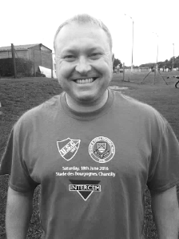
Please keep up your support and get behind the team, it is appreciated by the players. Enjoy the game and have a safe trip home.

Manders

Matt Farrell – 100 appearances
Congratulations to Matt Farrell who should make his 100th appearance today, becoming the 117th player in club history to reach this mark.

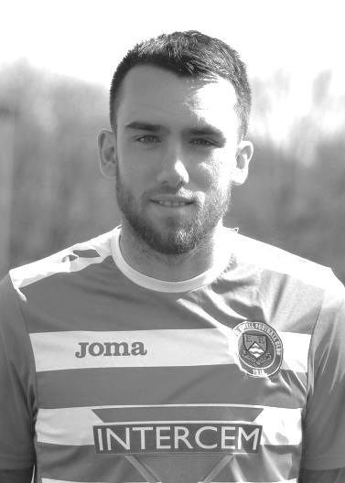
Matt made his debut on the opening day of the 2014/15 season at Farnham Town, scoring on his debut and becoming only the second player to score in both the first and last matches in their debut season when netting at Frimley Green.

In his time with the club he has gained a reputation for being one of the fittest, if not the fittest player we have ever had at the club. His relentless and dynamic work rate is easily noticeable on the field and in recent times has added more goals to his tally, reaching double figures from midfield last season and will surely pass last season’s tally of eleven as he has six already.

Matt has also Captained the club on a number of occasions in his time with us and is regularly supported by his parents who rarely miss a match.

Congratulations Matt, hopefully there will be a lot more appearances and goals to come in our colours.

Dave Wilson – 10 Years ago
This coming Wednesday it will be exactly ten years since we lost our much-missed Club Secretary Dave Wilson.

Following a Youth team match at home to Ashford Town (Mx) on the evening of 13th September at Merland Rise, Dave suffered a stroke, collapsing in the Board Room and passed away the following afternoon.

One of this club’s proudest recent achievements in my opinion is to have created and perpetuated the Dave Wilson Trophy in his memory and this year will be the tenth such event.

Although these days the Tournament is no longer arranged on a four team format, the intention is one day to return to that plan, but it may have to wait until we are able to return to a new home in the Borough before it will happen again.

In recent years the tournament has often taken the shape of a pre-season friendly against landlords Chipstead, but this year we had a small scare when we were unable to play the fixture before the League season commenced, due to the Football Association’s decision to bring the F.A. Cup forward to such an early stage of the season, but the fates have intervened in our favour for a change as we have been drawn at home to Chipstead in the Surrey Senior Cup and this match will now double with that tie as the tenth Dave Wilson Trophy match.

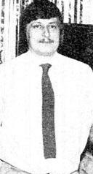
This contest will now take place on Tuesday December 6th and we would appreciate it if you all marked the date in your diaries and came along that evening.

We are of course also looking for sponsors for the match, so if you would like to do this, please get in touch with a Committee Member. Thank you.
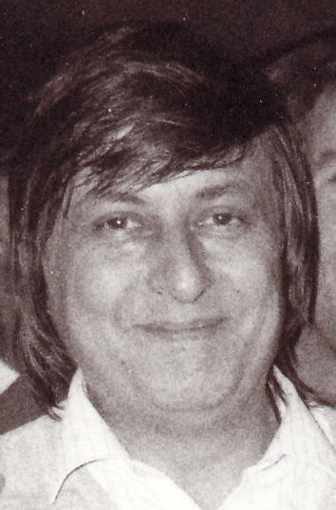

First Eleven Appearances 2016/17 - (max 9)
Name | Debut | 2016/17 |  |  |  | Career Totals
 |  | App | Sub | Total | Goals | App | Sub | Total | Goals
CLARK-GLEAVE Charlie | 23/08/2016 | 1 | 0 | 1 | 0 | 1 | 0 | 1 | 0
COOPER-SMITH Daryl | 03/01/2015 | 9 | 0 | 9 | 11 | 39 | 8 | 47 | 31
DEAN Dan | 02/08/2014 | 4 | 1 | 5 | 0 | 72 | 5 | 77 | 2
EACOTT Michael | 02/08/2014 | 6 | 0 | 6 | 0 | 91 | 1 | 92 | 0
FARRELL Matt | 02/08/2014 | 9 | 0 | 9 | 6 | 95 | 4 | 99 | 24
FERDINANDO Matt | 20/09/2014 | 3 | 1 | 4 | 1 | 56 | 7 | 63 | 15
GALLAGHER Jordan | 07/08/2016 | 2 | 4 | 6 | 2 | 2 | 4 | 6 | 2
GRIFFIN Reisse | 08/08/2015 | 7 | 1 | 8 | 0 | 35 | 7 | 42 | 2
HASTINGS Craig | 08/08/2015 | 6 | 2 | 8 | 0 | 43 | 6 | 49 | 0
HEAGNEY Adam | 16/08/2015 | 4 | 2 | 6 | 0 | 4 | 2 | 6 | 0
HENDRY Rob | 08/08/2015 | 6 | 3 | 9 | 1 | 36 | 14 | 50 | 13
MCKAY Alex | 20/12/2008 | 1 | 2 | 3 | 0 | 109 | 32 | 141 | 8
NEALE Tom | 13/10/2015 | 3 | 2 | 5 | 4 | 19 | 21 | 40 | 14
NORTH Rhys | 16/08/2015 | 2 | 2 | 4 | 0 | 19 | 9 | 28 | 1
PANAYIOTOU Savvas | 03/01/2015 | 4 | 2 | 6 | 0 | 36 | 10 | 46 | 7
PRICE Matt | 23/08/2016 | 2 | 0 | 2 | 1 | 2 | 0 | 2 | 1
ROBINSON Sam | 22/10/2011 | 7 | 1 | 8 | 1 | 61 | 6 | 67 | 14
TANTON Matt | 02/08/2014 | 7 | 1 | 8 | 0 | 64 | 5 | 69 | 2
TAYLOR James | 26/08/2013 | 9 | 0 | 9 | 0 | 95 | 12 | 107 | 6
THOMPSON Elliott | 09/02/2016 | 3 | 0 | 3 | 1 | 7 | 9 | 16 | 1
TURPIE Alistair | 31/03/2016 | 3 | 0 | 3 | 0 | 5 | 0 | 5 | 0
WATRET Jack | 02/08/2016 | 1 | 0 | 1 | 0 | 1 | 0 | 1 | 0

Latest Results and Fixtures
Combined Counties League Cup First Round – Tuesday 6th September
CB Hounslow United | 3-4 | Farnham Town
Cobham | 3-2+ | Bagshot
Epsom & Ewell | 1-0 | Abbey Rangers
Knaphill | 0-2 | Camberley Town
Westfield | 3-2 | North Greenford United
Combined Counties League – Tuesday 6th September
Badshot Lea | 3-4 | Colliers Wood United
Hartley Wintney | 6-2 | AFC Hayes
Spelthorne Sports | 3-3 | Windsor
Combined Counties League Cup First Round – Weds 7th September
Redhill | 4-0 | Bedfont & Feltham
Match played at Bedfont & Feltham F.C.
Combined Counties League – Wednesday 7th September
Guildford City | 6-1 | Chertsey Town
F.A. Vase First Qualifying Round – Friday 9th September
Badshot Lea | V | Farnham Town
Combined Counties League – Saturday 10th September
Epsom & Ewell | V | Camberley Town
Hartley Wintney | V | Knaphill
Walton & Hersham | V | Sutton Common Rovers
F.A. Vase First Qualifying Round – Saturday 10th September
AFC Hayes | V | Crawley Green
Arundel | V | Westfield
Bedfont & Feltham | V | Sandhurst Town
Bedford | V | CB Hounslow United
Bridon Ropes | V | Colliers Wood United
Chertsey Town | V | Lydney Town
Daventry Town | V | Windsor
Guildford City | V | Eastbourne United
Hanworth Villa | V | Bedfont Sports
Horley Town | V | Hassocks
Raynes Park Vale | V | Haywards Heath Town
Shrivenham | V | Abbey Rangers
Spelthorne Sports | V | Tring Athletic
Stotfold | V | North Greenford United
Combined Counties League – Monday 12th September
Abbey Rangers | V | Windsor
Latest Results and Fixtures
Combined Counties League Cup First Round – Tuesday 13th September
Spelthorne Sports | V | Sutton Common Rovers
Combined Counties League – Tuesday 13th September
Hanworth Villa | V | Walton & Hersham
Knaphill | V | Chertsey Town
North Greenford United | V | Bedfont & Feltham
Westfield | V | Raynes Park Vale
Combined Counties League Cup 1st Round –
Wednesday 14th September
South Park Reserves | V | Balham
Combined Counties League – Wednesday 14th September
Colliers Wood United | V | Bedfont Sports
Guildford City | V | Farnham Town
F.A. Cup Second Qualifying Round – Saturday 17th September
Merstham | V | Colliers Wood United
Combined Counties League – Saturday 17th September
Badshot Lea | V | Epsom & Ewell
Bedfont Sports | V | Sutton Common Rovers
Camberley Town | V | North Greenford United
CB Hounslow United | V | Windsor
Farnham Town | V | Bedfont & Feltham
Guildford City | V | Hanworth Villa
Horley Town | V | Hartley Wintney
Knaphill | V | Abbey Rangers
Raynes Park Vale | V | Walton & Hersham
Spelthorne Sports | V | Westfield
Combined Counties League – Tuesday 20th September
AFC Hayes | V | Colliers Wood United
Bedfont & Feltham | V | Camberley Town
Chertsey Town | V | Hanworth Villa
Horley Town | V | Abbey Rangers
Raynes Park Vale | V | Farnham Town
Westfield | V | Knaphill
Combined Counties League – Wednesday 21st September
Bedfont Sports | V | Badshot Lea
Combined Counties League – Saturday 24th September
Epsom & Ewell | V | Knaphill

From behind the goal
Epsom & Ewell 1-0 Abbey Rangers
Combined Counties League Cup - First Round - Tuesday 6th September 2016

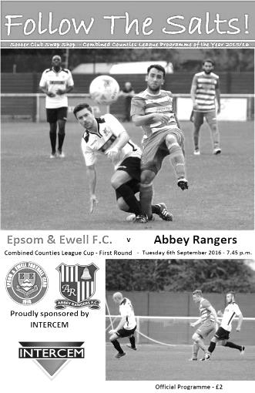
Late drama the only memory as Salts squeeze through in Cup

What appeared to be a sporting and well contested contest for 85 minutes degenerated badly towards the end with only 19 players remaining on the pitch by the final whistle. In fact it was easy to forget that we had won the match at this point, or indeed what the score was! That might sound a bit of an odd statement, but what with an early goal, a missed penalty, a disallowed goal and all sorts of trouble at the end, the result itself will be long forgotten when other memories of this match remain.

Following our win over Horley Town eight days previously we kept the same starting eleven, which meant that Rob Hendry made his 50th appearance for the club while Craig Hastings has to wait a little longer. Abbey Rangers had also stuck with the same eleven following their 4-0 win over Badshot Lea on Saturday but we were the ones who were first to show. In fact only 25 seconds were on the clock when Daryl Cooper-Smith had a try from 25 yards that might well have crept in the top corner had it not been deflected for a corner. From the set piece Dan Dean rose almost unchallenged to head at goal but Liam Stone tipped the ball over the bar. We had a scare moments later when Michael Eacott called for a ball but the call was late and Dean headed the ball behind him for an unnecessary corner but nothing came of it.

We were on the attack again quickly and good work from Reisse Griffin down the right resulted in a pull back to Adam Heagney whose delivery found Matt Farrell at the far post. He took a touch and fired at goal only to see the ball strike the far post and fly to safety. Stone had got a faint touch on the ball but it was impossible to say whether it was enough to divert it onto the post or whether the powerful strike would have hit it anyway.

Still Farrell would not be denied and he put us ahead in the 17th minute. James Taylor put a good ball through to him and he controlled the bouncing ball well before slamming the ball past Stone into the far corner. There were appeals for handball but from where I was standing you could see quite clearly that Farrell controlled the ball with his chest only. Agi Panayiotou had a try from 20 yards soon after but a deflection took the power off the ball and made for an easy save in the end.

We were continuing to attack at this point with the visitors not really getting into the game and Daryl Cooper-Smith nipped ahead of his defender to meet a Hendry cross with a header but was unable to hit the target with it, when a firmer contact would have done. We had another worry in first half injury time when a corner for the visitors was flicked on but the far post header went across goal and out for a goal kick.

Moments later though we had a chance to wrap it up. We played some nice football on the edge of the Abbey box and when the ball was threaded through to Sam Robinson he was fouled and the penalty given. After a couple of minutes treatment during which he looked in some considerable pain the defender Aristide was booked. Under the new rules this then meant that Robinson did not have to leave the field, so he promptly took the ball from Hendry so that he could take the

penalty. Now hindsight is a wonderful thing, but as he was still limping in the run up to the penalty, you wondered whether he had made the right choice and the penalty came at a good height for Stone who dived to his left to make the save. The whistle blew for half time immediately afterwards.

The good news was that Robinson was able to continue for the second half, although the second period was a more even contest. The visitors can play some nice football and both teams had spells of possession, although without causing any real drama in the danger areas. Hendry glanced a header wide from a Griffin cross but was at full stretch and did well to reach it in the first place while Robinson saw his left footed goalbound shot headed clear by a defender with the keeper already committed. In the 80th minute a Robinson free kick was met by a fine header from Dean but his header at the far post was met by an equally good save by Stone who just got enough on the ball to turn it round the post. The visitors also had a good chance from a free kick themselves but the header was just over the bar from close range.

Two minutes later came the key moment in the match. As Robinson stood over the ball on the edge of the area after a foul on Panayiotou after a great run, everyone was expecting the shot on goal, but he cleverly played the ball into the path of the substitute Jordan Gallagher who took a touch before hitting the post with his shot. The ball rebounded out and Griffin got to the ball before his defender to make it 2-0 by knocking the loose ball in. Or so we thought. A late flag for offside against Griffin was hard to understand at first, although was apparently given because whilst there was a defender between Griffin and the goal line, he was ahead of the keeper, who would of course usually be the second man.

Either way the decision to disallow the goal was slightly late and caught our guys off guard as we were still celebrating and as Abbey took the free kick quickly, many of our boys were left upfield and Matt Tanton conceded a necessary foul on the half way line. However, Danny Hartlebury then appeared to tread on Tanton and it all went off. All 22 players ventured towards the middle of the field. Eacott wisely decided not to go too far but his opposite number Stone ran 50 yards to get involved; not the wisest thing to do when you are wearing a different colour to everyone else! He became involved with Cooper-Smith as the trouble continued and took a few minutes to settle down. Although I was critical of the decision to disallow the goal and more importantly not giving our players time to retreat, the officials took their time and calmly, systematically picked out the main offenders in their eyes, sending Hartlebury and Stone off for the visitors along with Cooper-Smith and bookings for others.

After an extended period of injury time the final whistle blew and the bare facts were that we had earned a trip to Hanworth Villa in the next round. Overall it was a deserved win as we were significantly the better team in the first half, but on another day we might have been pegged back for extra time. Many opportunities came and went, arguably more than in our 7-1 win over the same opposition two weeks previously and if we had taken some in the first half, who knows how many we might have ended up with, but as we will shortly miss Cooper-Smith for three matches as a result of the red card, it was good to see Tom Neale returning for a quick cameo in the final minutes of the match. Then again, we could always play Farrell up front as he already has six goals to his name this season, more than most strikers in this League!

Epsom and Ewell: Michael Eacott, Adam Heagney, James Taylor, Dan Dean (c),
Savvas 'Agi' Panayiotou, Rob Hendry, Matt Farrell, Daryl Cooper-Smith,
Sam Robinson, Reisse Griffin

Subs: Jordan Gallagher for Hendry (75), Tom Neale for Robinson (90)

Club Records - 10th September
Date | Day | Competition |  | Opponents |  | Scorers
10/09/27 | Sat | London League | A | Chelmsford | 1-1 | F.Watts
10/09/30 | Wed | Surrey Charity Shield 1 | A | Whyteleafe Albion | 5-0 | E.Matkin (4), T.Birch
10/09/32 | Sat | Surrey Charity Shield 1 | H | Carshalton Athletic | 2-0 | G.Mackesy, B.Gill (pen)
10/09/38 | Sat | London League | H | Eton Manor | 2-1 | R.Forbes, D.Wilson
10/09/49 | Sat | Corinthian League | H | Hounslow Town | 2-4 | L.Hanton, B.Cutter
10/09/55 | Sat | Friendly | A | Beckenham | 5-1 | B.Musto (2), J.Berry, D.Hermitage, o.g.
10/09/60 | Sat | F.A. Cup Preliminary Round | H | Carshalton Athletic | 0-1
10/09/66 | Sat | Athenian League 2 | A | Lewes | 0-4
10/09/77 | Sat | London Senior Cup 1q | H | Thames Polytechnic | 1-0 | T.Tuite
10/09/83 | Sat | F.A. Trophy Preliminary Round | H | Hornchurch | 5-0 | S.Hill (2), R.Harmsworth, P.Harding, C.Miles
10/09/85 | Tue | Isthmian League  Premier Division | A | Bishop's Stortford | 1-2 | R.Lewis
10/09/86 | Wed | Isthmian League 1 | A | Leytonstone/Ilford | 0-2
10/09/88 | Sat | Isthmian League 2s | A | Hungerford Town | 1-1 | K.Phillips
10/09/05 | Sat | F.A. Cup 1q | A | Camberley Town | 0-1
10/09/11 | Sat | F.A. Vase 1q | A | Hailsham Town | 3-1 | R.Burns (2), M.Harmsworth
10/09/13 | Tue | Combined Counties  League Cup 1 | A | Horley Town | 3-2 | K.Douglin, K.Hough, M.Jarman
Historical Decades
Date | Day | Competition |  | Opponents |  | Scorers
90 years ago – Epsom Town F.C.
11/09/26 | Sat | Surrey Senior League | H | Addlestone | 7-2 | R.Marlow (4), R.Sperring (2), J.Parr
80 years ago – Epsom F.C.
12/09/36 | Sat | London League | H | Tilbury | 7-1 | H.Pullen (5), T.Dunne (2)
70 years ago – Epsom F.C.
07/09/46 | Sat | London League | H | Ekco | 3-2 | S.Scott (2), D.Ralph
60 years ago – Epsom F.C.
15/09/56 | Sat | Corinthian League | A | Maidstone United | 3-5 | J.Bangs (3, 1 pen)
50 years ago – Epsom & Ewell F.C.
10/09/66 | Sat | Athenian League 2 | A | Lewes | 0-4
40 years ago – Epsom & Ewell F.C.
11/09/76 | Sat | Athenian League 1 | H | Marlow | 4-1 | G.O'Rourke (2), M.Peters, T.Tuite
30 years ago – Epsom & Ewell F.C.
10/09/86 | Wed | Isthmian League 1 | A | Leytonstone/Ilford | 0-2
20 years ago – Epsom & Ewell F.C.
09/09/96 | Mon | Isthmian League Cup 1 | A | Chesham United | 3-3+ | P.Meredith, M.Owen, K.Webb
10 years ago – Epsom & Ewell F.C.
09/09/06 | Sat | Combined Counties  League Cup 2 | A | CB Hounslow United | 1-2 | D.Marvell

History Corner – 10th September
90 years ago this week we started what would become a record breaking season with a 7-2 home win over Addlestone in the Surrey Senior League. Reg Marlow scored four of what would become a club record of 65 goals on our way to a League and League cup double.

86 years ago today we travelled to New Barn Lane, home of Whyteleafe Albion in the Surrey Charity Shield and battered them 5-0 with E.G. Matkin scoring four of the goals. Terry Birch scored the other as we romped home against a forerunner of the current Whyteleafe club, although there is no connection between the two.

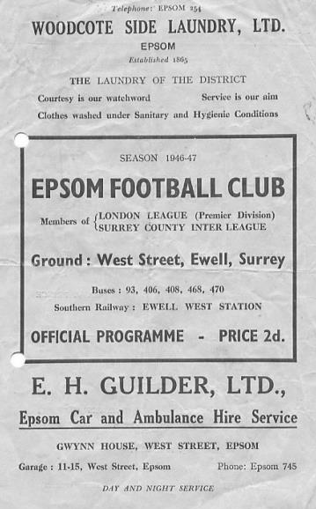
80 years ago this week we defeated Tilbury 7-1 in the London League with Jackie Pullen scoring five of the goals. Matches between ourselves and Tilbury were almost always home wins, with either team considering themselves fortunate to even secure a point on the ground of their opponents!

70 years ago this week we defeated Ekco 3-2 in a London League match at West Street with Stan Scott scoring twice and Don Ralph getting the other one (see programme pictured). Ekco were a works team owned by Mr E.K.Cole and they were massive in those days, being responsible for a number of things in post war Britain, but most memorably, radios. They were based in Southend and we went there seven days later for a London League Cup tie, losing 2-1!

60 years ago this week we were beaten 5-3 at Maidstone United in a Corinthian League match, but this day would be remembered for the debut of young striker Johnny Bangs who scored a hat trick after we had been 5-0 down! He would go on to set the second highest post war tally of 53 goals, still the third highest total in club history.

30 years ago today there is a personal record. Myself and Gary Vickers completed a 24 mile sponsored walk to the Hare and Hounds ground, home of Leyton Wingate, where Leytonstone and Ilford were ground sharing, for a league match. Unfortunately we lost 2-0, although fortunately we were able to get a lift back home!

11 years ago today we were defeated 1-0 in the F.A. Cup by Camberley Town at Krooner Park. We had already won there once in the Associate Members Trophy and dominated this match, only to concede to a long range looping header which was pretty much their only attack on the day. Frustrating!

Finally, Russell Harmsworth scored for us this day in a 5-0 Trophy win over Hornchurch 1983 and 28 years later his son Matt scored for us in a Vase tie at Hailsham Town!

Camberley Town – History
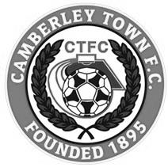
The football club was founded at St. Michael’s Church in Yorktown in 1895 and was initially named St. Michael’s, Camberley. The first trophy was won in the club's second season when Norwood & Selhurst were beaten 2-1 in the 1898 Surrey Junior Cup final. The club joined its first league, the East & West Surrey League, for the 1898-99 season and finished third.

In 1901 the club looked likely to fold for financial reasons but, after a public meeting, a new club named Camberley & Yorktown was formed by members of the St. Michael's committee. Camberley & Yorktown took the place of St. Michael's in the East & West Surrey League before joining the Aldershot Combination in 1902 followed by the Ascot & District League in 1903 where the club won four titles and finished second three times in the seven years spent in the league. The club went on to appear in three more Surrey Junior Cup finals, the first of which was in 1908 when Camberley & Yorktown took on Kingston at Woking and were beaten 2-0. The following season also resulted in a defeat in the final this time losing 1-0 to Selhurst Park. The 1909-10 season saw victory at last as Camberley & Yorktown defeated Sutton United 2-1 at Kingston.

The club moved to the West Surrey League in 1910 and in 1913 made their first appearances in both the F.A. Cup and F.A. Amateur Cup. On September 13th Camberley & Yorktown played host to Sutton United and won 5-3 in their first F.A. Cup match. The first F.A. Amateur Cup game was disappointing though as Camberley & Yorktown were soundly beaten 7-0 by the Royal Army Medical Corps, however the club went on to win the league title that season.

After World War I Camberley & Yorktown concentrated their efforts on the Aldershot Senior League until 1922 when the club submitted an application to join the newly formed Surrey Senior League. The application was accepted so Camberley & Yorktown became founder members of the league and remained in it for over 50 years. The club moved into their present ground at Krooner Park in 1923. The ground had been paid for from the winnings of a racehorse named 'Krooner' at Haydock Park in 1920. The 1930’s saw unequalled success at the club as they won the Surrey Senior League title three seasons running from 1931 to 1933 and appeared in the final of the Surrey Senior Cup in 1936 where they were beaten 3-1 by Wimbledon at Champion Hill, Dulwich.

After World War II Camberley & Yorktown dropped the 'Yorktown' part of their name. Krooner Park was not ready for use by the time the league resumed after the war so the club started the season at the London Road Recreation Ground which had been one of the grounds used before the move to Krooner Park. Success was hard to come by with only a victory in the Surrey Senior Charity Cup in 1952 against Chertsey and a further appearance in the final 3 years later to show for their efforts during the 50s and 60s.

In 1967 discussions took place regarding a merger between the club and the other senior club in the town, Camberley Wanderers. Wanderers had been formed as a youth football club in 1950 but moved into adult football in 1965 joining the Parthenon League

but they had no ground of their own. On the 2nd of June 1967 the merger went through and both clubs became Camberley Town F.C. The first notable season as Camberley Town came in 1972-73 when third place was achieved in the league alongside an appearance in the League Charity Cup final at Weybridge where they lost 3-2 to Westfield. In a bid to bring a higher grade of football to the town the club joined the Spartan League in 1973 and installed floodlights in 1974. The official opening of the floodlights saw what is believed to be a record home attendance of around 3,500 people watch Camberley draw 1-1 with Malcolm Allison's Crystal Palace team.

In 1975 Camberley joined the Athenian League followed by the Isthmian League in 1977. Promotion to Division One of the Isthmian League was achieved in 1979 along with victory in the final of the Surrey Senior Cup where Leatherhead were beaten 4-1 after extra time at Imber Court. However, collapse soon followed and within three seasons Camberley found themselves back in the Athenian League and struggling on and off the pitch. Expansion of the Isthmian League in 1985 gave Camberley a route back into the league which was gratefully accepted.

In 1986 the Club enjoyed their best run in the F.A. Vase reaching the quarter finals where they went out to eventual winners Halesowen Town. The Aldershot Senior Cup was won in 1997 and 1998. 1997-98 also saw Camberley reach the Fourth Qualifying Round of the F.A. Cup equalling their best performance in the competition since the 1930's. In the league they missed out on promotion on the final day of the season. In 1998-99 Camberley went one better in the F.A. Cup reaching the First Round Proper for the first time where they were knocked out by Division 3 side Brentford.

Following the disbanding of the Isthmian League Second Division in 2006 Camberley were placed in the Combined Counties League and have since secured their best run of league placings for many years. In 2009 the club won the Combined Counties Premier Challenge Cup for the first time beating Worcester Park 3-0 in the final at Carshalton Athletic F.C.

Current first team manager Dan Turkington took the helm during 2012-13 season. The club finished in second place in the league in both 2014 and 2015. 2015 saw the club winning two cup competitions in one season for the first time. Colliers Wood United were beaten 2-1 after extra time in the Combined Counties Premier Challenge Cup final at Woking F.C. and Fleet Town were beaten on penalties after a 0-0 draw in the Aldershot Senior Cup final at Aldershot Town F.C.

The 2015/16 season was a memorable one, even if ultimately the club ended with little to show for their efforts. Most importantly the club repeated their 1985/86 achievement in reaching the Quarter-Final of the F.A. Vase only to lose out 3-2 in extra time at eventual finalists Hereford after leading twice. The League was equally frustrating as a defeat to Hartley Wintney on the final day of the season meant that they just missed out on a third consecutive second place. This time it would have earned promotion and insult was added to injury when Farnham Town defeated them 3-1 in the Combined Counties Premier Challenge Cup Final, although a measure of revenge was gained as they defeated the same opponents to win the Aldershot Senior Cup.

Centre page for results

Centre page for results

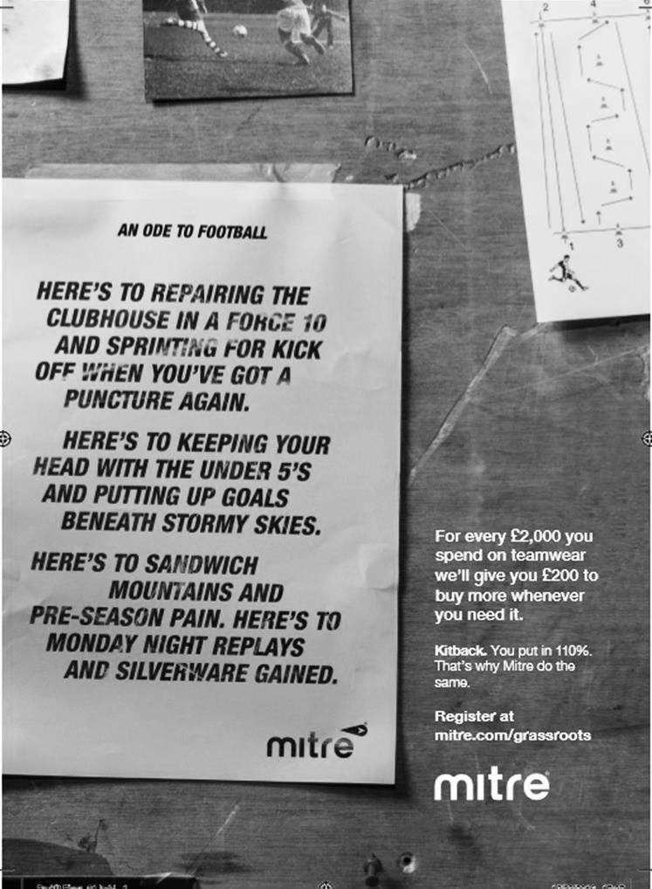

Every Opponent A-Z
Over the years we have played many, many different opponents. Exactly how many is a difficult question, as it all depends on your definition. Are Camberley & Yorktown different to Camberley Town, or are Epsom Town different to Epsom F.C. or Epsom & Ewell F.C.?

In my analysis I have classed both of the above examples as the same team, and will work through them all from A to Z. Some we have played many times, whilst others we have met just once or twice. Enjoy!

Stevenage Borough / Stevenage: Played 3 - W0 D1 L2 - F3 A6 - PPG - 0.33 - Awful
Over the years we have played a number of clubs who have found their way into the Football League. Cheltenham Town, Wycombe Wanderers, Yeovil Town, Barnet, Newport County and even Crawley Town, but I bet most of you forget Stevenage, who as Stevenage Borough met us in the1986/87 season.

We travelled to Broadhall Way, substantially underdeveloped in comparison to the fine stadium they have today, back on 25th October 1986 where we were second best but nearly held on for a goalless draw before being defeated by a thunderbolt of a finish from their substitute in the 82nd minute. If that was unjust, the return match at West Street on 14th March 1987 was even harsher as we led 2-0 against ten men, only to somehow concede twice to drop two points in a draw. Always remember that we went down by a single point in 1986/87!

The Stevenage Borough club were not the first team to exist in the town and they were preceded by a Professional outfit playing in the Southern League for a while. Stevenage as they were then called, visited West Street on 16th September 1967 for an F.A. Cup tie, winning 3-1, although they didn’t last much longer. Strictly speaking I maybe should have had these two clubs as separate entities but I didn’t. Hey, it’s my list!!

Streatham Town: Played 11 - W6 D2 L3 - F29 A21 - PPG - 1.82 - Very Good

We go back to the nineteen thirties for this one. Streatham Town were founded in 1928 and entered the Surrey Senior League in 1932/33 finishing midway down the table. It is not clear how they were then elected to the London League, bearing in mind that we had actually needed to win the Surrey Senior League to get in just seven years previously!

Still they were a decent London League outfit, finishing in midtable in 1933/34 and reaching the London League Cup Final in each of the following two seasons, winning it in 1935/36 before losing their ground in 1937 and changing their name before disappearing into oblivion shortly afterwards.

Our first meeting came in the London League at West Street on 16th December 1933 and resulted in a 4-1 win with two goals coming from Ernest Flight, a future Club Treasurer who is buried in Epsom Cemetery. Tommy Dunne scored the only goal in the return on 3rd February 1934 on our first ever visit to Hassocks Road which was (and still is) in Streatham Vale.

The 1934/35 season would contain five meetings between the two clubs. We were drawn there in an F.A. Cup First Qualifying Round tie on 29th September 1934 where we achieved a 2-2 draw with goals from Dunne and Michael Wiggins but the replay on the following Wednesday afternoon was one of the strangest matches ever seen at West Street as Streatham raced off to a 3-0 lead in the opening twenty minutes, only for them to be swamped by seven Epsom goals. The visitors scored a late consolation under unusual circumstances as the offside flag went up but Williamson the former Epsom player went on anyway and put the ball in the net. The referee then discussed matters with the Linesman and overruled him. It was even described in the Epsom

Herald report as “a queer goal”!

If that wasn’t enough the two teams met at Christmas in League action with strange results. We lost 4-1 in Streatham on Christmas Day but despite changing just one player in our line up (Geoff Collins for Michael Wiggins) for the return match on Boxing Day, we won 7-1 at West Street!

They would have the last laugh though when defeating us 1-0 in the Semi-Final of the London League Cup in a match played for some reason at Colston Avenue, home of Carshalton Athletic on Monday 29th April 1935. Back then the League Cup was a very minor competition and the result didn’t even appear in the official Epsom records book from the thirties that I have, and indeed no match reports have yet been found for this match, with exception of a brief paragraph in the Epsom Herald!

In 1935/36 we met in League matches, winning 2-0 at home on 5th October 1935. Their player Leslie Green was clearly impressed and decided to join us instead, playing the next week and scoring twice in our club record 13-1 Amateur Cup win over Reigate Priory. However, we were not a good team that season and crashed 5-0 in Streatham in the return match on our way to finishing tenth out of thirteen.

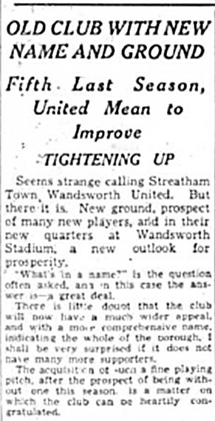
Our final visit to Hassocks Road came on 12th December 1936 where we secured a 1-1 draw and on 27th March 1937 we completed a perfect record of five wins out of five at West Street with a 4-2 win.

At the end of the season they left the London League and were replaced by Wandsworth United, playing at the much larger Greyhound Stadium. It appeared at first as though they were a completely separate team, until very recently when I uncovered a report (see above) showing that Streatham were losing their ground and because they were now playing at Wandsworth they had changed their name. This would explain their continuity in the London League and so…

Wandsworth United: Played 5 - W5 D0 L0 - F20 A5 - PPG - 3.00 - Perfect

Although competing as League equals Wandsworth United first met us in a Christmas friendly in 1937 when a Tommy Rochester hat trick helped us to a 5-2 win. We met in League action on 15th January 1938 when we won at the Greyhound Stadium by two goals to one despite the presence of young striker Gordon Brogdale in their line-up, having just joined from Epsom a week or two previously. On 16th April 1938 it was Basil Solly’s turn for a hat trick in a 6-1 win at West Street.

By the start of 1938/39 things had taken a turn for the worse as Wandsworth had lost their ground which would eventually become the site of the large shopping centre there but were allowed by the London League to play all their matches away from home. We thrashed them 5-0 on 22nd October at West Street in our official home match and our final meeting came on Saturday 25th February 1939, winning 2-1. Whether they folded or were just not accepted, they never appeared in the constitution for the ill-fated 1939/40 season and are not in any way connected with the later Wandsworth club that became Wandsworth and Norwood and latterly Croydon Athletic.

CCL Premier Division Club Directory
ABBEY RANGERS Telephone: 01932-422962 - Ground: Addlestone Moor, Addlestone, Surrey KT15 2QH - Colours: Black & White Stripes/Black/Black

A.F.C. HAYES Telephone: 0208-845-0110 - Ground: Farm Park, Kingshill Avenue, Hayes, Middx. UB4 8DD - Colours: Blue and White Stripes/Blue/Blue

BADSHOT LEA Telephone: 01252-320385 - Ground: Ash United FC, Shawfield Stadium, Youngs Drive, Shawfields Road, Ash, Hampshire. GU12 6RE - Colours: Claret/White/Claret

BEDFONT & FELTHAM Telephone: 0208 890 7264 - Ground: The Orchard, Hatton Road, Bedfont, Middx TW14 9QT - Colours: Yellow & Blue/Blue/Blue

BEDFONT SPORTS Telephone: 0208-831-9067 - Ground: Bedfont Sports Club, Hatton Road, Bedfont, Middx TW14 8JA - Colours: Red & Black Hoops/Black/Red & Black Hoops

CAMBERLEY TOWN Telephone: 01276-65392 - Ground: Krooner Park, Wilton Road, Camberley, Surrey. GU15 2QW - Colours: Red & White Stripes/Blue/Red

CB HOUNSLOW UNITED Telephone: 0208 890 7264 - Ground: The Orchard, Hatton Road, Bedfont, Middx TW14 9QT - Colours: Green/Black/Green

CHERTSEY TOWN Telephone: 01932-561774 - Ground: Alwyns Lane, Chertsey, Surrey. KT16 9DW - Colours: Royal Blue & White Stripes/Royal Blue/Royal Blue

COLLIERS WOOD UNITED Telephone: 0208-942 8062 - Ground: Wibbandune Sports Ground, Robin Hood Way, Wimbledon. SW20 0AA - Colours: Blue & Black Stripes/Black/Black
EPSOM & EWELL Telephone: 01737-553250 - Ground: Chipstead FC, High Road, Chipstead, Surrey. CR5 3SF - Colours: Royal Blue & White Hoops/Royal Blue/Royal Blue

FARNHAM TOWN Telephone: 01252-715305 Ground: Memorial Ground, Babbs Mead, West Street, Farnham, Surrey. GU9 7DY Colours: - Claret & Sky Blue /White/ Claret & Sky Blue

GUILDFORD CITY Telephone: 01483-443322 - Ground: The Spectrum, Parkway, Guildford, Surrey. GU1 1UP - Colours: Red & White Stripes/Black/Black

HANWORTH VILLA Telephone: 0208-831-9391 - Ground: Rectory Meadows, Park Road, off Hounslow Road, Hanworth, Middlesex. TW13 6PN - Colours: Red & White Stripes/Black/Black

HARTLEY WINTNEY Telephone: 01252-843586 - Ground: Memorial Playing Fields, Green Lane, Hartley Wintney, Hants RG27 8DL - Colours: Orange & Black/ Orange /Orange

HORLEY TOWN Telephone: 01293-822000 - Ground: The New Defence, Anderson Way, Court Lodge Road, Horley, Surrey. RH6 8SP - Colours: Claret & Sky Blue/Claret/Claret

KNAPHILL Telephone: 01483-475150 - Ground: Brookwood Country Park, Redding Way, Lower Guildford Road, Knaphill, Surrey. GU21 2AY - Colours: Red/Black/Red

NORTH GREENFORD UNITED Telephone: 0208 422 8923 - Ground: Berkeley Fields, Berkeley Avenue, Greenford, Middx UB6 0NX - Colours: Royal Blue & White/Royal Blue/Royal Blue

SUTTON COMMON ROVERS Telephone: 01932-866386 - Ground: Sutton United FC, Gander Green Lane, Sutton, Surrey SM1 2EY - Colours: Yellow/Black/Black

RAYNES PARK VALE Telephone: 020-8540-8843 - Ground: Prince Georges Playing Field, Grand Drive, Raynes Park, London. SW20 9NB - Colours: Blue/Blue/Red

SPELTHORNE SPORTS Telephone: 01932-961055 - Ground: Spelthorne Sports Club, Staines Road, Ashford Common, Ashford, Middx. TW15 1RY - Colours: Light & Dark Blue/Dark Blue/Light Blue

WALTON & HERSHAM Telephone: 01932 245263 - Ground: Stompond Lane, Walton on Thames, Surrey KT12 1HF - Colours: Red/Red/Red

WESTFIELD Telephone: 01483-771106 - Ground: Woking Park, Kingfield Road, Woking, Surrey. GU22 9BA - Colours: Yellow/Black/Black

WINDSOR Telephone: 01753-860656 - Ground: Stag Meadow, St Leonards Road, Windsor, Berks SL4 3DR - Colours: Red/Red/Red

Combined Counties League Premier Division Opponents
All-time Records
incl Tuesday 6th September | P | W | D | L | F | A | PPG | GD | Best  Win | Worst  Loss
Bedfont & Feltham | 1 | 1 | 0 | 0 | 9 | 2 | 3.00 | +7 | 9-2 | X
Abbey Rangers | 2 | 2 | 0 | 0 | 8 | 1 | 3.00 | +7 | 7-1 | X
Spelthorne Sports* | 5 | 4 | 1 | 0 | 15 | 6 | 2.60 | +9 | 6-2 | X
Sutton Common Rovers | 10 | 8 | 1 | 1 | 27 | 12 | 2.50 | +15 | 4-0 | 1-4
Horley Town | 29 | 20 | 5 | 4 | 65 | 30 | 2.24 | +35 | 6-0 | 1-3
Colliers Wood United | 22 | 14 | 2 | 6 | 45 | 33 | 2.00 | +12 | 4-0 | 0-5
Westfield | 18 | 11 | 3 | 4 | 39 | 29 | 2.00 | +10 | 6-1 | 0-4
Bedfont Sports | 9 | 5 | 2 | 2 | 13 | 10 | 1.89 | +3 | 3-0 | 0-4
Farnham Town | 13 | 7 | 2 | 4 | 23 | 22 | 1.77 | +1 | 3-1 | 1-4
Guildford City | 16 | 9 | 1 | 6 | 32 | 22 | 1.75 | +10 | 5-1 | 1-5
Hanworth Villa | 14 | 7 | 3 | 4 | 34 | 24 | 1.71 | +10 | 5-0 | 1-4
Raynes Park Vale | 26 | 13 | 5 | 8 | 57 | 36 | 1.69 | +21 | 6-1 | 0-2
Knaphill | 6 | 3 | 1 | 2 | 11 | 8 | 1.67 | +3 | 4-1 | 1-2
Walton & Hersham | 49 | 24 | 9 | 16 | 100 | 96 | 1.65 | +4 | 6-0 | 0-8
Camberley Town* | 88 | 38 | 21 | 28 | 158 | 123 | 1.53 | +35 | 9-1 | 0-4
Hartley Wintney | 10 | 4 | 3 | 3 | 25 | 17 | 1.50 | +8 | 5-0 | 2-4
Badshot Lea | 17 | 7 | 3 | 7 | 31 | 33 | 1.41 | -2 | 4-1 | 0-4
Windsor | 48 | 18 | 12 | 18 | 88 | 90 | 1.38 | -2 | 4-0 | 0-6
Chertsey Town | 47 | 17 | 5 | 25 | 70 | 86 | 1.19 | -16 | 3-0 | 0-7
AFC Hayes | 8 | 2 | 2 | 4 | 16 | 15 | 1.00 | +1 | 7-0 | 0-3
CB Hounslow United | 2 | 0 | 0 | 2 | 2 | 7 | 0.00 | -5 | X | 1-5
* includes one abandoned match v Camberley and one loss on penalties v Spelthorne

EL Records Premier Challenge Cup
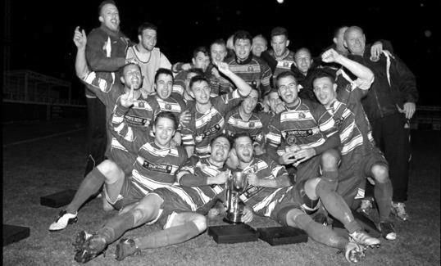
First Round
Redhill | 4-0 | Bedfont & Feltham
Match played at Bedfont & Feltham F.C.
Spelthorne Sports | 13/9 | Sutton Common Rovers
Knaphill | 0-2 | Camberley Town
Worcester Park | 24/9 | Dorking
Epsom & Ewell | 1-0 | Abbey Rangers
Westfield | 3-2 | North Greenford United
Cobham | 3-2+ | Bagshot
CB Hounslow United | 3-4 | Farnham Town
South Park Reserves | 14/9 | Balham
Second Round
Hanworth Villa | 11/10 | Epsom and Ewell
AFC Hayes | 4/10 | 9
Epsom Athletic | 28/9 | Windsor
2 | V | Bedfont Sports
Raynes Park Vale | 4/10 | Colliers Wood United
Frimley Green | 4/10 | Banstead Athletic
Westfield | 4/10 | Redhill
Staines Lammas | 15/10 | Farnham Town
4 | V | Cove
Badshot Lea | 4/10 | Guildford City
Chertsey Town | 4/10 | Camberley Town
Cobham | V | Chessington & Hook United
Hartley Wintney | 4/10 | AC London
Horley Town | 4/10 | Sheerwater
Walton & Hersham | 4/10 | Eversley & California
Ash United | 11/10 | Farleigh Rovers

Surrey Senior Cup
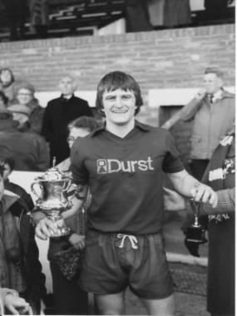
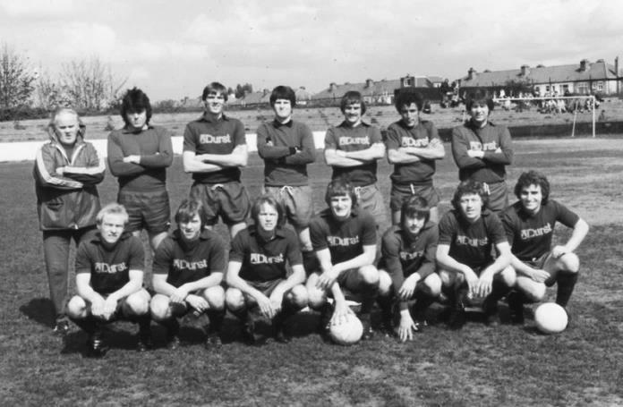
First Round
Abbey Rangers | V | AFC Croydon Athletic
Whyteleafe | V | Westfield
Second Round
Kingstonian | V | Met Police
Ashford Town (Mx) | V | Knaphill
Woking | V | Walton Casuals
2 | V | Colliers Wood United
Guildford City | V | Horley Town
Egham Town | V | Corinthian Casuals
Godalming Town | V | Merstham
Molesey | V | Leatherhead
Raynes Park Vale | V | Sutton United
Sutton Common Rovers | V | Camberley Town
Dorking Wanderers | V | South Park
Badshot Lea | V | Farnham Town
Walton & Hersham | V | Croydon
Carshalton Athletic | V | Tooting & Mitcham United
Chertsey Town | V | 1
Epsom & Ewell | 6/12 | Chipstead

Player Sponsorship
Here is the opening list for the 2016/17 season showing all of our players and Management that are currently available for sponsorship.

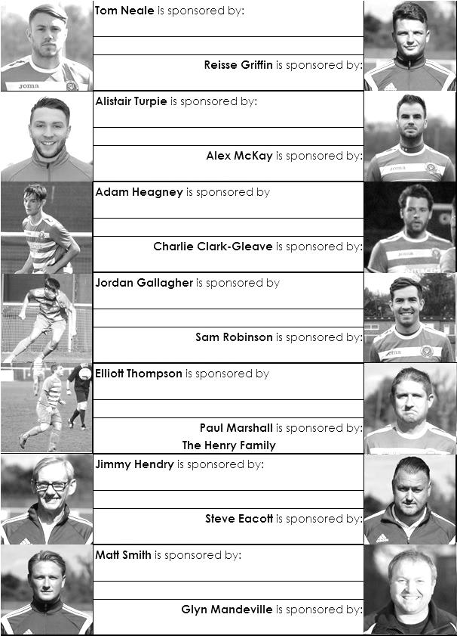

Sponsorship costs just £40 and it is easy to do. Just select a player who has not been previously sponsored and let a Committee Member know that you would like to sponsor them. Beware though. Until we have received the money it is possible for someone to jump in front of you, so don’t delay, sponsor today!
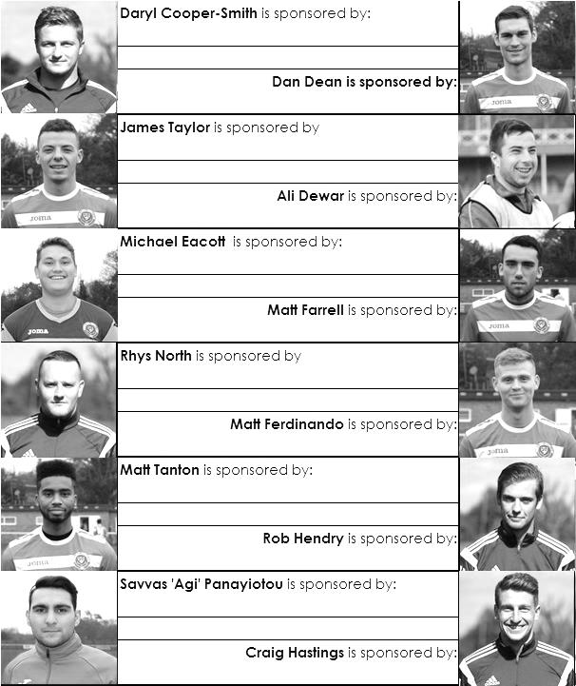

Match and Ball Sponsorships – 2016/17
Opponent | Date | Match Sponsor | Ball Sponsor
Gravesham Borough | 07/08/16 | Club President - Stella Lamont
Gravesham Borough | 07/08/16 | Relocation Committee Member - Mike Lovett
CB Hounslow United | 16/08/16 | EEFC Management Committee
Abbey Rangers | 23/08/16 | Steve & Geoff Dyke
Horley Town (11.30am) | 29/08/16 | In Memory of Chris Henry
Abbey Rangers (LC) | 06/09/16 | Paul Merritt
Camberley Town | 10/09/16 | Building Shop Ltd
Knaphill | 24/09/16
Sutton Common Rovers | 08/11/15
Windsor | 15/11/16
Bedfont Sports | 19/11/16
AFC Hayes | 26/11/16
Chipstead (SSC) | 06/12/16
Hanworth Villa | 13/12/16
Chertsey Town | 17/12/16
Raynes Park Vale (11.30am) | 27/12/16
Spelthorne Sports | 07/01/17
Guildford City | 17/01/17
Bedfont & Feltham | 21/01/17 | Programme Editor - Richard Lambert
Badshot Lea | 04/02/17
Westfield | 18/02/17
Walton & Hersham | 04/03/17
Hartley Wintney | 18/03/17
Farnham Town | 25/03/17
Colliers Wood United (1.00pm) | 14/04/17 | Good Friday match – make a note!
North Greenford United | 22/04/17
 | tba | F.A. Vase – if drawn at home
For League, League Cup and Surrey Senior Cup Matches:
Match sponsorship - £40.00 Match ball sponsorship - £25.00. Combined £55.00.
For F.A. Cup and F.A. Vase matches:
Match sponsorship - £50.00 Match ball sponsorship - £30.00. Combined £65.00.

Sponsorship includes: (x2 for match, x3 for match and ball)

Admission, programmes, hospitality and advertising and mascot for the day (if required).
If you are interested, just speak to a Committee Member, or drop me an email at: richard.c.lambert@gmail.com

We also thank our Kit Sponsors INTERCEM

Salts Super Six Predictor
The Salts Super Six Predictor is live again for today’s match and the tickets are on sale at today’s game to the left of the gate.

The competition is easy to play! To win, you simply need to predict the results of six matches correctly from the three options, fill in the form and make sure it is back with our seller before the deadline on the ticket. The latest fixtures are shown here and you will see that we are back to the Premier League today.

If you are a club regular, you just need to place your name on the sheet, although if you aren’t, then we’ll need a contact number from you too. We will announce any winners on the website within three working days, so don’t worry, we won’t miss you!

We had a big jackpot winner last year and who knows how much could be won this time! It is currently £165 and you’ll always know the size of the pot before you enter.

Please note that if there is more than one winner, the prize pot would be shared between the winners. All you need to do now is have a go, as many times as you like!

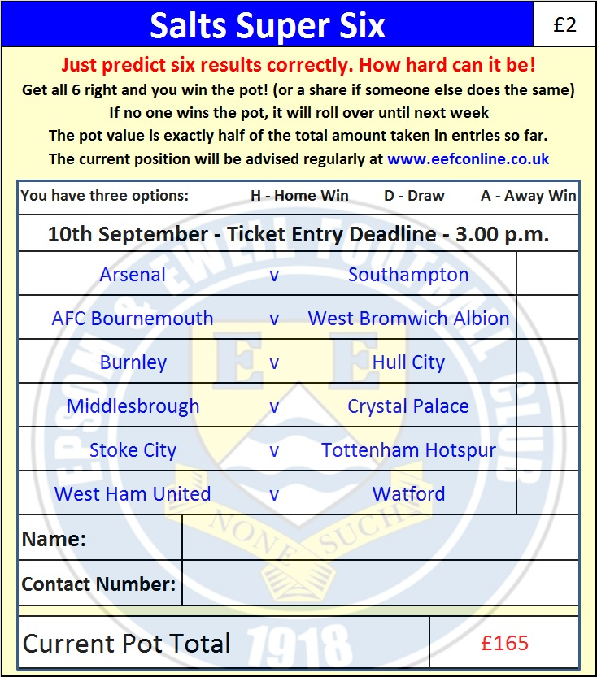

Good luck!

Combined Counties League – Premier Division
Saturday, 10th September 2016 - Kick-off 3.00 p.m.
Epsom and Ewell  (Royal Blue & White hoops) | V |  | Camberley Town  (Red and White)
Squad | NUMBERS
Michael Eacott |  |  | Ryan Bell
James Taylor |  |  | George Boughton
Matt Tanton |  |  | Matthew Bunyan
© Dan Dean |  |  | Jonathan Burch
Craig Hastings |  |  | Marcus Cousins
Savvas ‘Agi’ Panayiotou |  |  | Paul Dadson
Rob Hendry |  |  | James Garrard
Matt Farrell |  |  | Carl Garstang
Daryl Cooper-Smith |  |  | Dean Greenwood
Sam Robinson |  |  | Zachary Hawker
Reisse Griffin |  |  | Jamie Hoppitt
Matt Ferdinando |  |  | Matthew Humphrey
Adam Heagney |  |  | Daniel Jewell
Alex McKay |  |  | Mark Jordan
Jordan Gallagher |  |  | Freddie Kelsey
Rhys North |  |  | Calum Nimmo
Alistair Turpie |  |  | Stuart Norman
Tom Neale |  |  | Joseph Pantony
Charlie Clark-Gleave |  |  | Emmanuel Quarshie
Manu Sale |  |  | Liam Roberts
Glyn Mandeville | MANAGER |  | Dan Turkington
Matt Smith | ASSISTANT
Steve Eacott / Alex McKay / Jimmy Hendry | COACHES / PHYSIO |  | Dean Greenwood / Sam Rafique, Mark Whiteley / Tony Phasey
REFEREE: A.Desai
ASSISTANTS: J.Crichlow, R.Wells
Today’s Match and Match Ball are sponsored
by Building Shop Ltd

OUR NEXT VISITORS TO HIGH ROAD
Knaphill
Combined Counties League – Premier Division
Saturday 24th September 2016 – 3.00 p.m.

